PedroClaveroDeDios_ProgrammingExercise_3
Pedro Clavero De Dios
February 22, 2026

Program Description: Monthly expense analyzer program that asks the user to enter their expenses by type and amount. The program uses the reduce method to calculate the total expenses, find the highest expense, and find the lowest expense, labeling each one.

Function: get_expenses
Asks the user for their monthly expenses.

Parameters:
None

Variables:
expenses (list): List of dictionaries with expense type and amount.
expense_type (str): The type of expense entered by the user.
amount (float): The amount of the expense.

Logic:
1. Initialize expenses as an empty list.
2. Loop to ask user for expense type and amount.
3. If user types 'done', stop collecting expenses.
4. Convert amount to float and append to list.
5. Return the list of expenses.

Return:
list: A list of dictionaries with 'type' and 'amount' keys.

Function: analyze_expenses
Uses reduce to calculate total, highest, and lowest expenses.

Parameters:
expenses (list): List of expense dictionaries.

Variables:
total (float): The total of all expenses.
highest (dict): The expense with the highest amount.
lowest (dict): The expense with the lowest amount.

Logic:
1. Use reduce with a lambda to sum all expense amounts for total.
2. Use reduce with a lambda to find the expense with the highest amount.
3. Use reduce with a lambda to find the expense with the lowest amount.
4. Return total, highest, and lowest.

Return:
tuple: The total expense, highest expense dict, and lowest expense dict.

Function: display_results
Displays the total, highest, and lowest expenses.

Parameters:
total (float): The total of all expenses.
highest (dict): The expense with the highest amount.
lowest (dict): The expense with the lowest amount.

Variables:
None

Logic:
1. Print the total expense amount.
2. Print the highest expense type and amount.
3. Print the lowest expense type and amount.

Return:
None

Function: main
Main function to run the expense analyzer program.

Parameters:
None

Variables:
expenses (list): List of expense dictionaries from user.
total (float): The total of all expenses.
highest (dict): The highest expense.
lowest (dict): The lowest expense.

Logic:
1. Get expenses from the user.
2. Check if any expenses were entered.
3. Analyze expenses using reduce.
4. Display the results.

Return:
None

Screenshot:
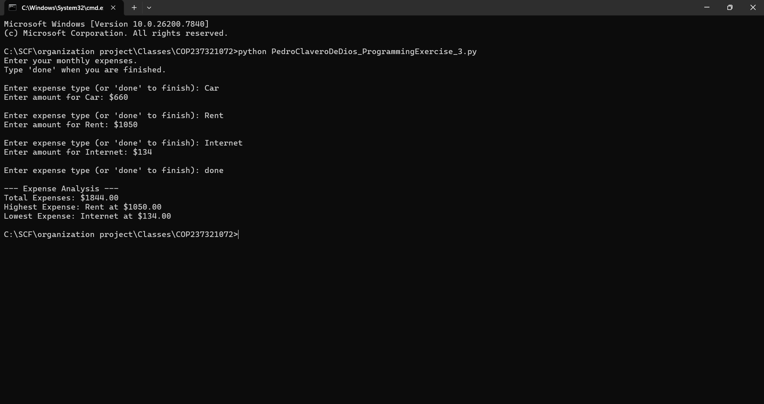
Link to repository: https://github.com/Pclav34/PC_COP2373

